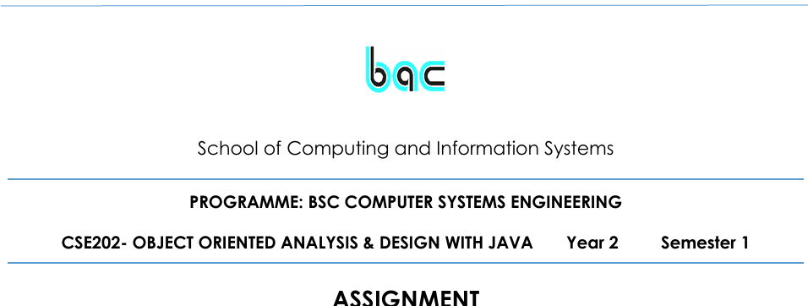

|  |  |  |
| --- | --- | --- |
| Requirements Elicitation | |  |
|  | | **STUDENT NUMBER CSE24-159** |
|  |  |  |
| 1.1 Functional RequirementsOverviewThe Banking System is designed to facilitate secure and efficient financial operations for individual and corporate customers. It supports multiple account types and provides essential banking functionalities through a user-friendly interface.Functional RequirementsAccount ManagementCustomers can open multiple types of accounts: Savings, Investment, and Cheque.The system must support deposits and withdrawals (where applicable).Account balances must be updated in real-time.Transaction HistoryCustomers should be able to view a detailed history of all transactions (deposits, withdrawals, interest payments).Each transaction must include a timestamp, amount, and account type.Interest Calculation and PaymentThe system must automatically calculate and apply monthly interest:5% for Investment services0.05% for Savings servicesInterest must be credited to the respective service balance **4.Withdraw Funds**   * Withdrawals are allowed only from Investment and Cheque accounts.  1.2 Non-Functional RequirementsSecurityAll user data must be securely stored and transmitted using encryption protocols.PerformanceThe system should respond to user actions within 2 seconds under normal load.It must support concurrent access by multiple users without degradation in performance.UsabilityThe interface must be intuitive and accessible to users with basic computer literacy.Clear navigation and feedback mechanisms should be provided.The system should be compatible with desktop and mobile platforms. **Maintainability**   * **The system should be modular and well-documented to facilitate easy updates, debugging, and enhancement**   **Scalability**  **The system should support a growing number of users and accounts without performance degradation.**  **3.Structural UML Modelling**  **2.1. System Use Case Diagram**      **2.2. Class diagram**      **3. Behavioural UML Modelling)**  **3.1.   Login and Deposit Sequence Diagrams:**      **3.2. State Diagram:**    **Appendix: Mock Interview Record**  **Interviewer:** Kentsenao Baseki **Interviewee:** Students **Date:** 18 September 2025 **Purpose:** To elicit functional requirements for the Banking System Q1: What types of accounts should be supported? *A1: Savings, Investment, and Cheque accounts, each with specific rules for deposits, withdrawals, and interest.*Q2: Should customers be able to hold more than one account? *A2: Yes, a customer can hold multiple accounts of different types.*Q3: Is transaction tracking important? *A3: Yes, customers must be able to view all their past transactions clearly.*Q4: What are the core services the banking system should offer? *A4: The system should allow customers to register, log in, manage multiple accounts, and view transaction history.* | | |
|  | | |
|  | | |